Uva Wellassa University of Sri Lanka Faculty of Applied Sciences  Department of Computer Science and Informatics  Undergraduate Research Project (CST/IIT)- 2024/2025 |  |  |  | 
PROGRESS REPORT Report No: |  |  |  | 02
Name of the student/s: | W.K.Gayan
Registration Number/s: | UWU/IIT/21/062
Degree Programme/s: | Industrial Information Technology
Title of the Study: | AI-Based Tomato Ripening Stage Detection and Sorting System with Shelf-Life Estimation for the Commonly Consumed Padma Variety in Sri Lanka Using Computer Vision and Conveyor Automation
Institute/s where studies  are affiliated with: | Uva Wellassa University of Sri Lanka
Name of the Supervisor/s: | Ms. D.P. Jayathunga(Principle supervisor)  Dr. U.G.A.T. Premathilake (Co-Supervisor)  Ms. M.P.A.M. Rathnakumara (Co-Supervisor)
Period of Progress: | From:01/02/2026 |  | To:28/02/2026
Progress (A description by the Student).
- Accomplished activities (during this progress period)
During this progress period, we converted the earlier hardware design plan and draft budget into a more detailed 3D prototype design in SolidWorks. The initial CAD layout includes the conveyor frame and belt path, motor mount, camera stand, lighting holders, actuator placement, and proposed sensor locations. This model was used to confirm dimensions and clearances, verify component fit against the draft budget, and make design adjustments before starting physical construction.
In addition, we trained a YOLOv8 multi-class detection model to detect and classify Padma tomatoes into the defined classes, supporting the project’s real-time grading and sorting objective.
Milestones achieved
- Initiated a detailed 3D conveyor prototype layout in SolidWorks aligned with the identified hardware list and draft budget.
- Designed/added key module representations (e.g., NEMA 17 motor and camera module concepts) and integrated mounting considerations for motor, camera, lighting, sensors, and actuator placement.
- Performed preliminary clearance and dimension checks to reduce part-to-part clashes before fabrication.
- Updated notes/documentation so that the latest hardware design, budget items, and intended physical prototype remain consistent.
- Trained a YOLOv8 multi-class detection model for ripeness-stage/quality classification to support real-time grading and sorting.

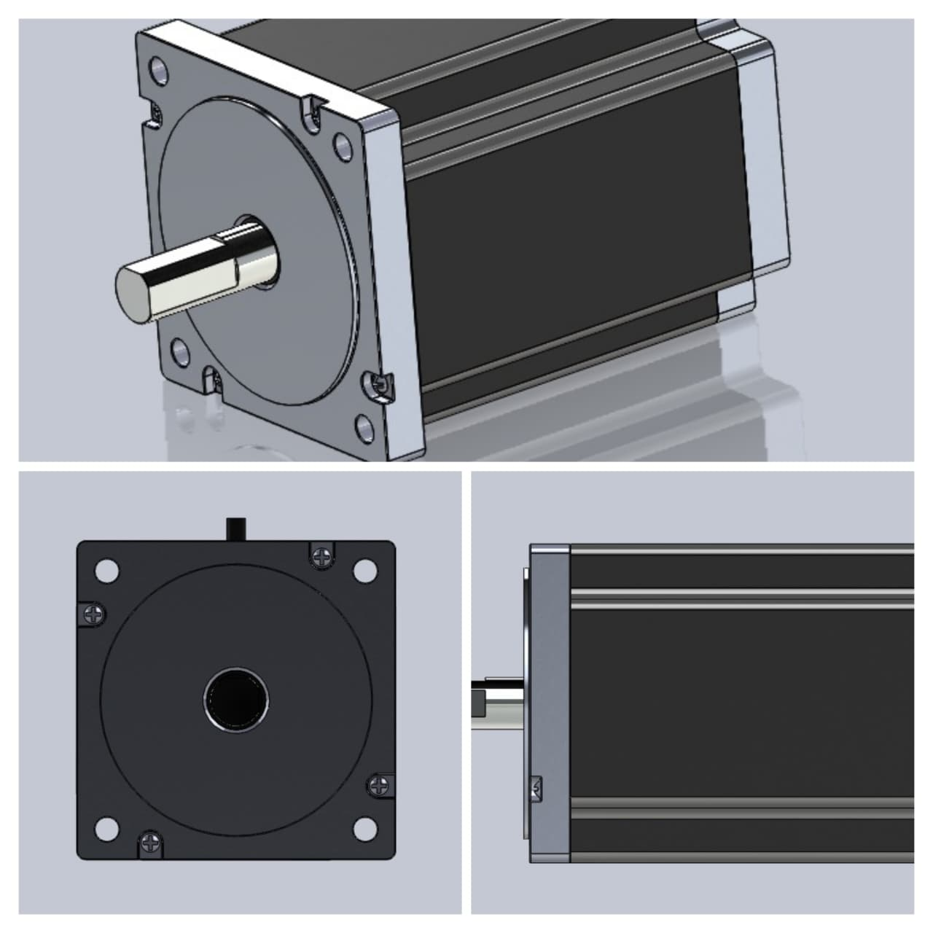
Figure 1: Nema 17 Motor design in SolidWorks

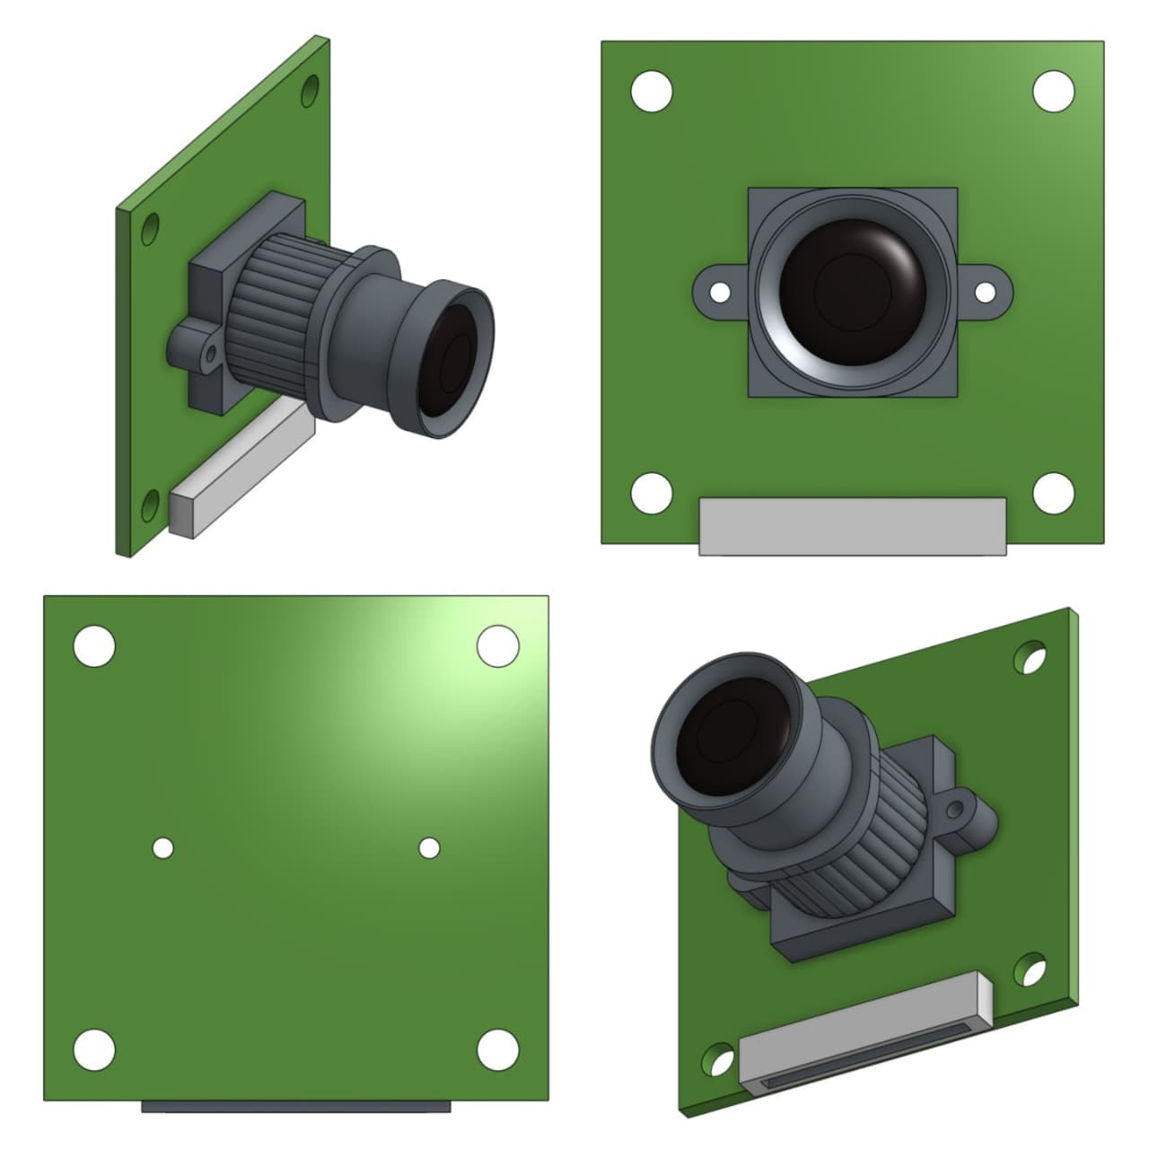
Figure 2: Camera module design in SolidWorks

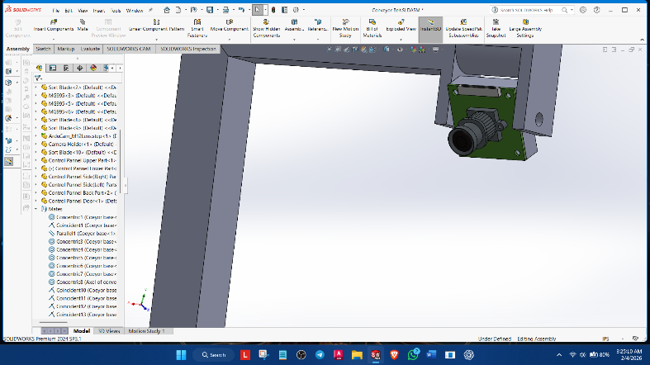
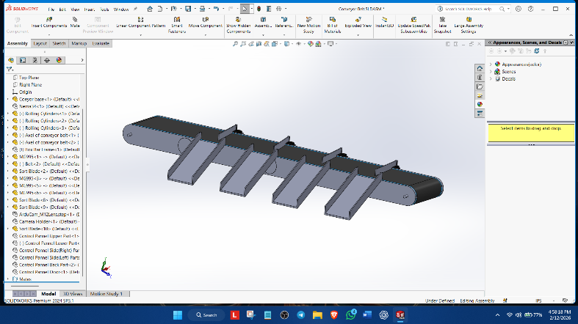
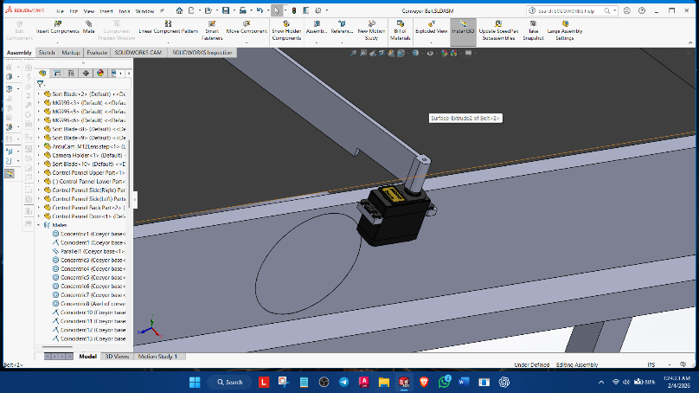
Figure 3: Draft designs created using SolidWorks
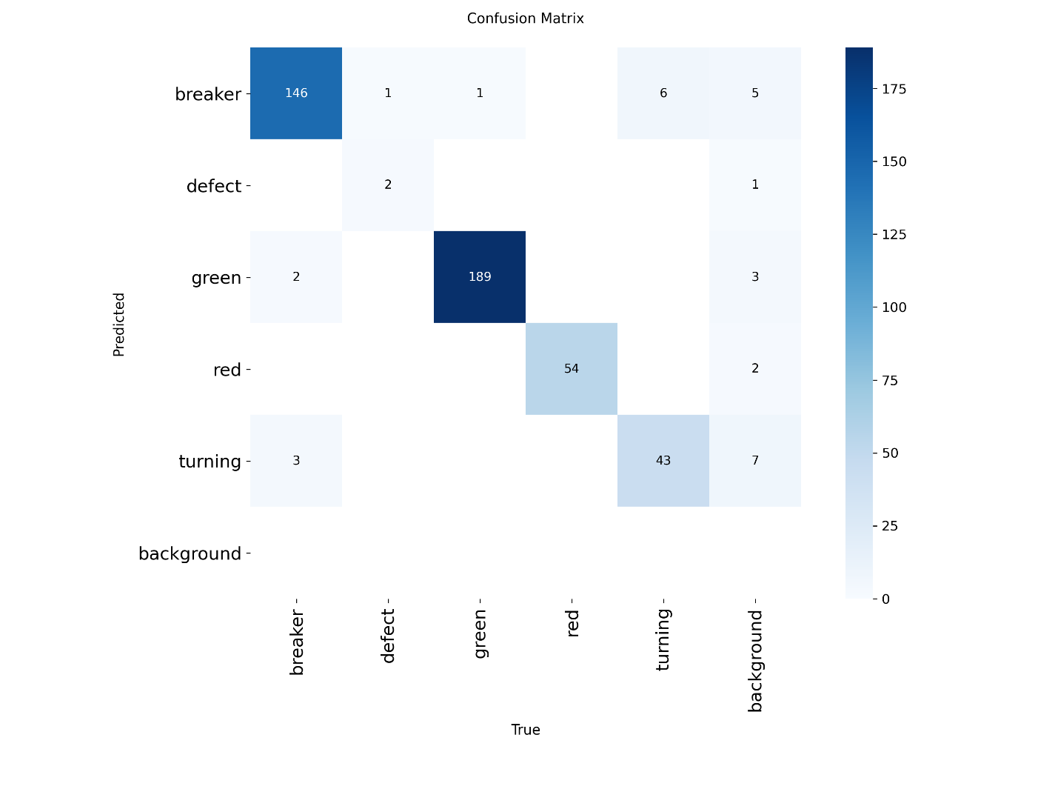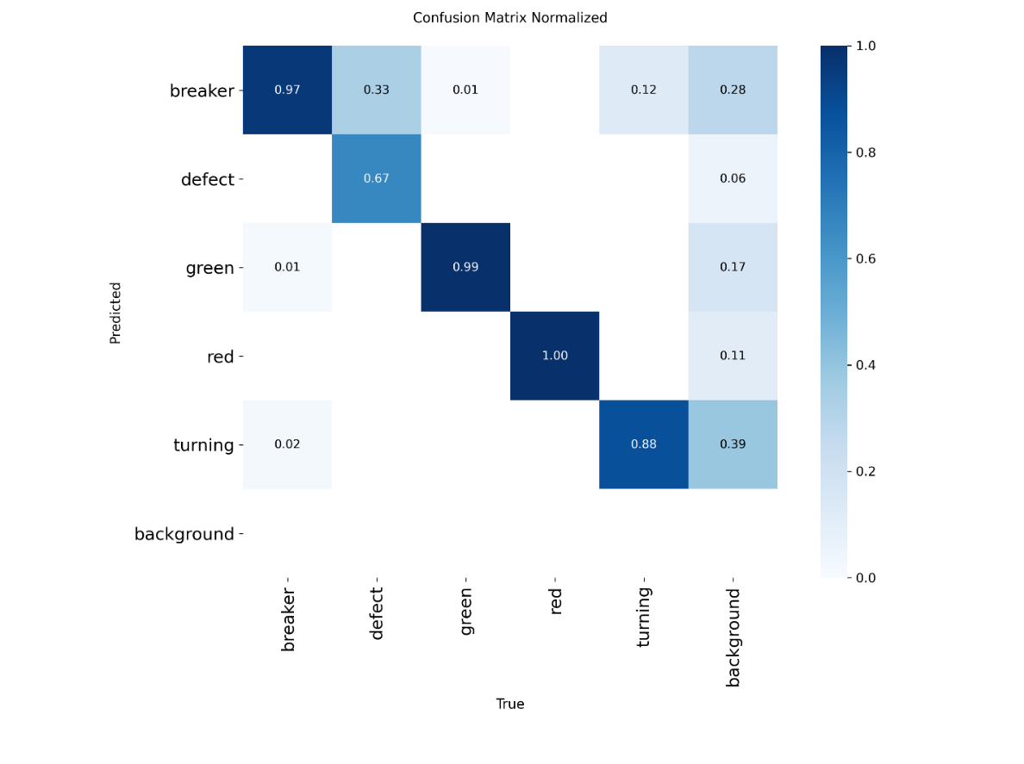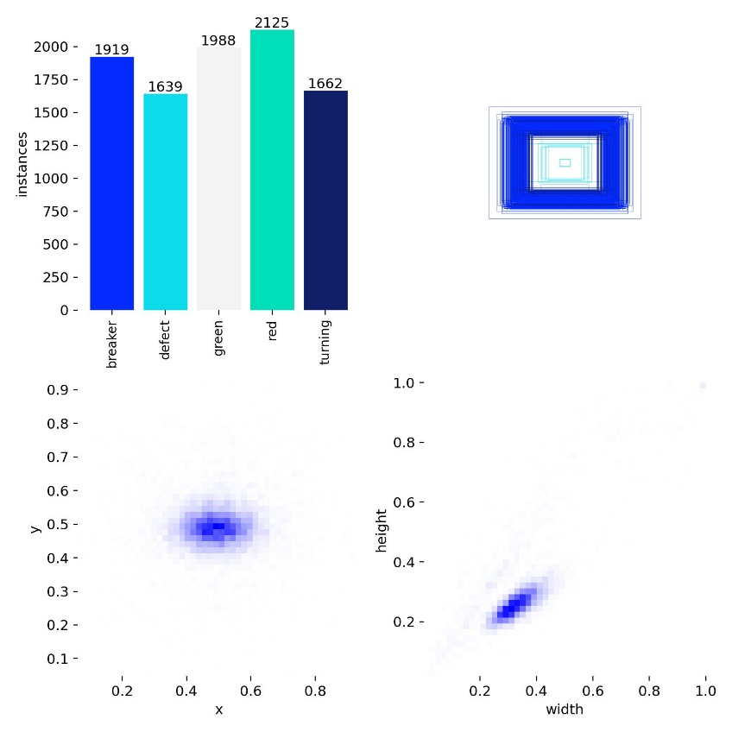
Figure 6 Dataset label statistics and instance distribution for the five-class tomato dataset used for YOLOv8 training (Breaker, Defect, Green, Red, Turning), including bounding-box size and position distributions.
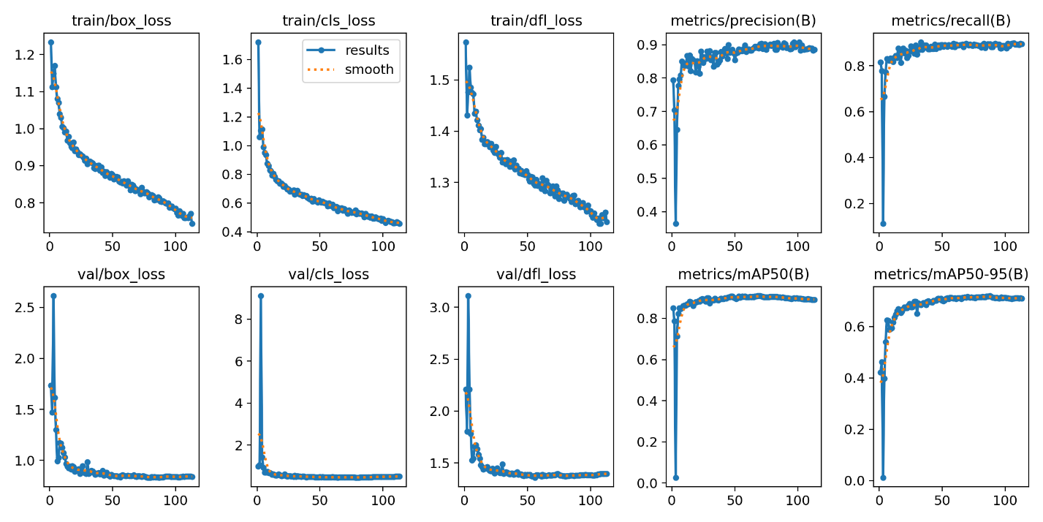
Figure 7 YOLOv8 training progress curves showing training/validation losses (box, cls, DFL) and detection metrics (precision, recall, mAP@0.5, mAP@0.5–0.95) across epochs.

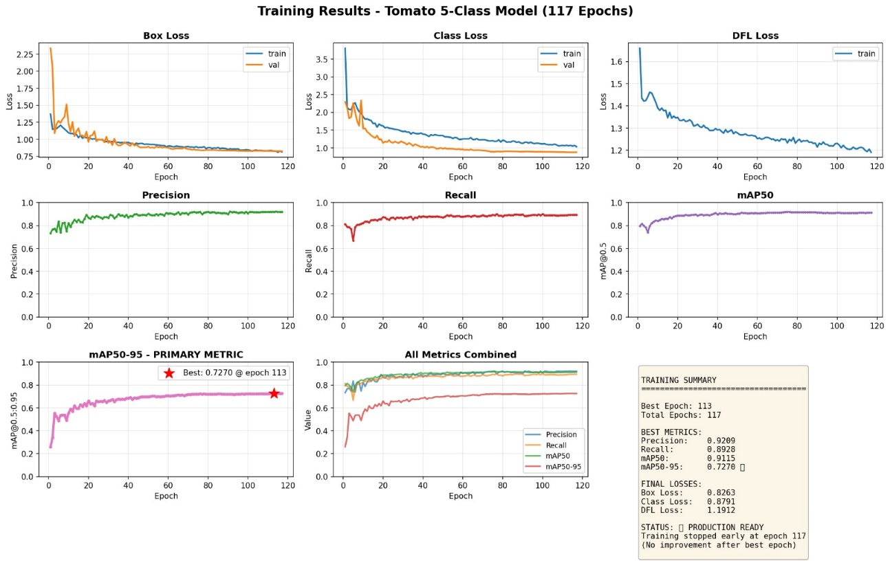
Figure 8 YOLOv8 5-class training results after correcting labels/annotations, showing updated loss curves and performance metrics (precision, recall, mAP@0.5, mAP@0.5–0.95) across 117 epochs, with the best epoch at 113
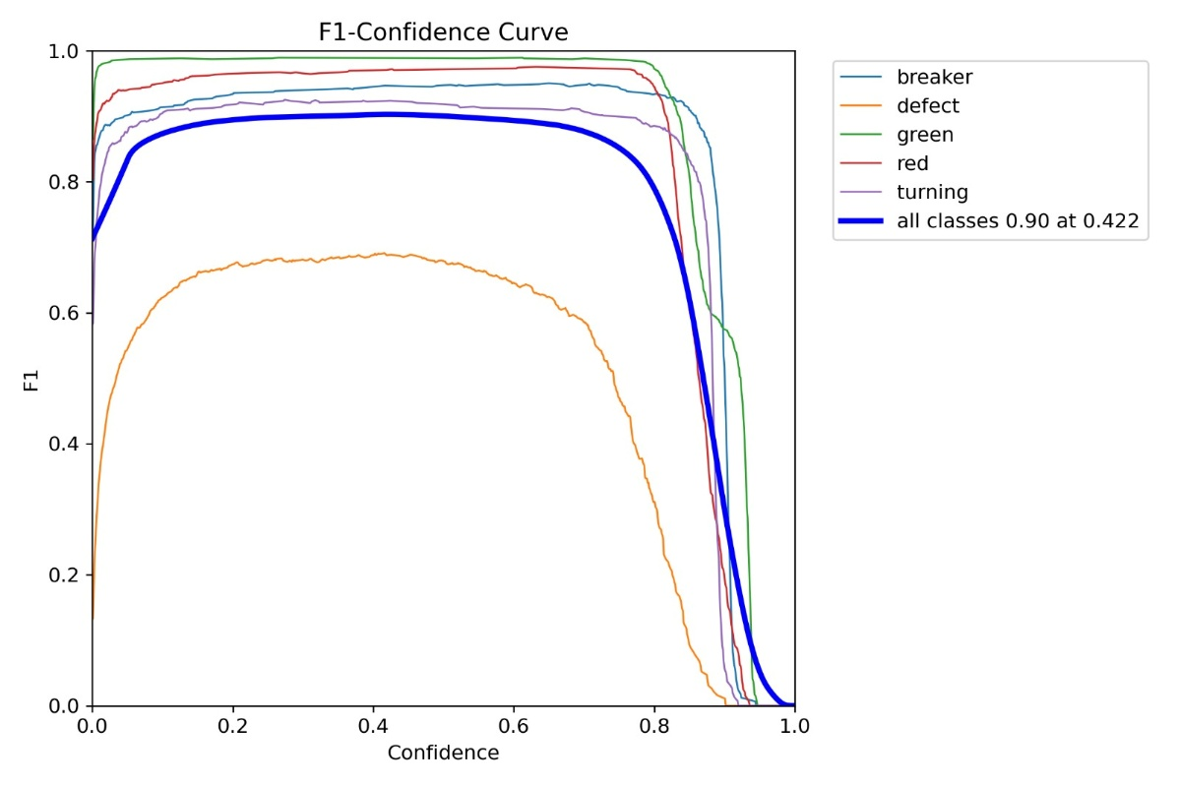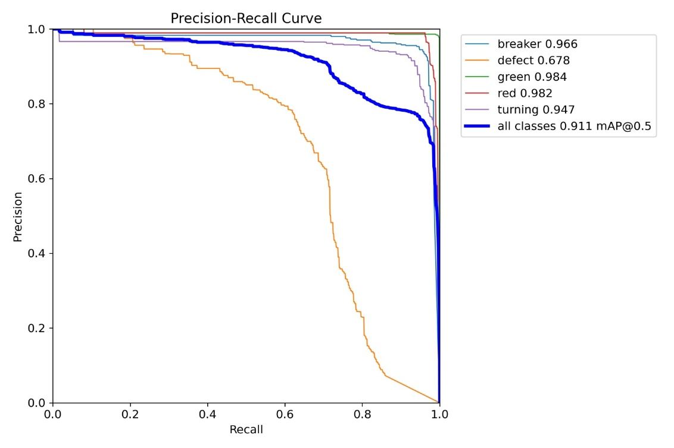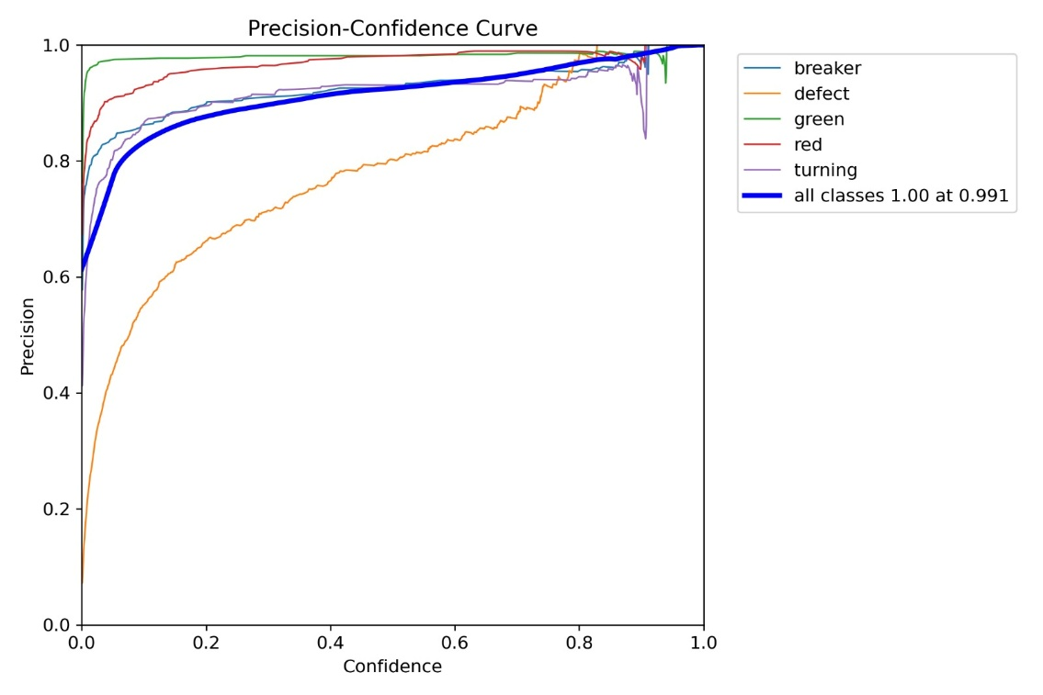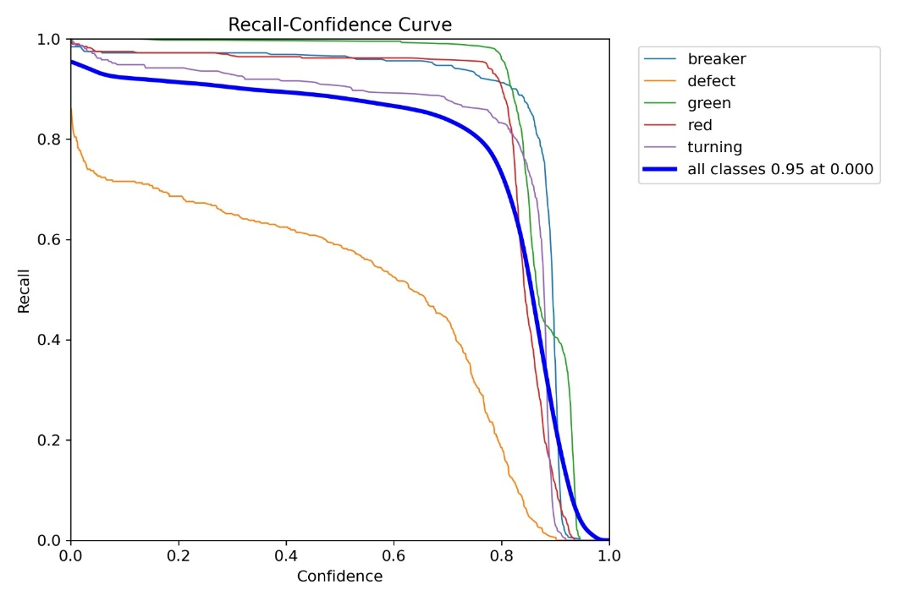

Activities planned to do before producing the next progress report (next progress period)
In the next progress period, the focus will be on finalizing the SolidWorks design into a build-ready prototype plan and preparing for early-stage physical implementation. This includes refining the CAD model based on clearance checks, confirming final mounting points, and aligning the finalized design with the procurement list and prototype assembly sequence.
Planned activities
- Finalize the conveyor/frame CAD design in SolidWorks with confirmed dimensions, tolerances, and mounting hole locations for all major components.
- Validate camera-to-sorting distance and sensor placement to support timing calculations based on conveyor speed.
- Update the component list and draft budget according to the finalized CAD design (confirm quantities, sizes, and any required changes).
- Prepare basic fabrication/assembly guidance from the CAD model (key drawings/views for frame and mounts).
- Plan the initial prototype assembly steps, including required tools and basic safety considerations for mechanical work.

Signature of the Student: |  | 
Approval Signature of Supervisor:
Approval Signature of Co-Supervisor (If any):
Date: |  | 12/02/2026

